DAY 1: Euler Paths and Circuits Name: ________________________
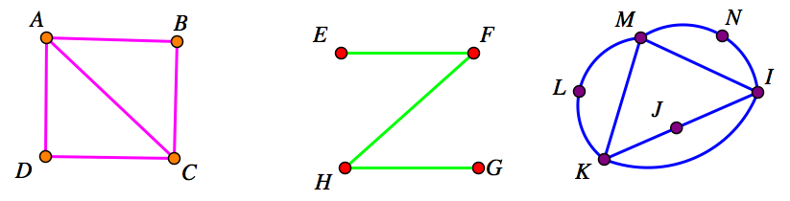
- Label the degree of each vertex above.

- Decide if each graph above is an Euler path. If so, provide an algorithm for that path.

- Decide if each graph above is an Euler Circuit. If so, provide an algorithm for that circuit.

- Make a graph which has six vertices and seven edges and is an Euler path.

Is your graph also an Euler Circuit? Why or why not?

