DAY 1: Euler Paths and Circuits Name: ________________________
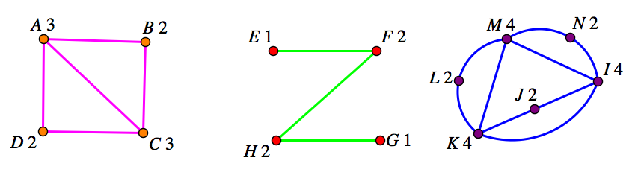
- Label the degree of each vertex above. (Done on the graphs above)

- Decide if each graph above is an Euler path. If so, provide an algorithm for that path.
The first graph is an Euler path: ABCDAC. The second graph is an Euler path: EFHG. The third graph is an Euler path: IJKLMNIMKI.

- Decide if each graph above is an Euler Circuit. If so, provide an algorithm for that circuit.
The first graph is not an Euler Circuit. The second graph is not an Euler Circuit. The third graph is an Euler Circuit: IJKLMNIMKI.

- Make a graph which has six vertices and seven edges and is an Euler path.
Multiple Answers. Below are two possible answers.
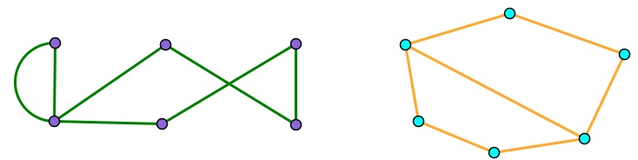
Is your graph also an Euler Circuit? Why or why not?
My graph is not an Euler circuit because since there are seven edges and six vertices, one of my vertices must have an odd degree.

