The Evolution of Mathematics Educational Standards from GPS to CCSS
Rebecca McDowell

Standards for educators and students have changed many times throughout the years. Google defines a standard as “an idea or thing used as a measure, norm, or model in comparative evaluations” (Google). The U.S. Department of Education defines standards as “College- and career-ready standards: Content standards for kindergarten through 12th grade that build towards college- and career-ready graduation requirements (as defined in this document) by the time of high school graduation. A State's college- and career-ready standards must be either (1) standards that are common to a significant number of States; or (2) standards that are approved by a State network of institutions of higher education, which must certify that students who meet the standards will not need remedial course work at the postsecondary level” (U.S. Department Of Education). Teachers use standards and curriculum maps as guides to what to teach to the students and when to teach it. Standards are grouped by grade-level, then subject, topic (actual standard), and lastly subtopic (substandard). Each state has created their own standards that their teachers use when designing lessons, and implementing instruction. The topics taught in mathematics are the same for each state. However, each state can determine when and in what order to teach the topics. This paper will inform the reader of the background and history of standards specifically for the state of Georgia. Next, the change from Georgia Performance Standards to the Common Core State Standards. This paper will also explain the pros and cons of standards and how standards not only affect teachers, but also students.
The idea of standards is not unfamiliar to the education world. Since the formal idea of school began, standards and expectations have been in place for the teachers and for the students. From one-room school houses to 35 students in a classroom, standards have been implemented to ensure the success of the students and to provide teachers with a guideline for the content material that needs to be taught to students. Standards began with the important ideas that every person needed to learn and has moved towards what people need to understand to be a wise and successful citizen. Standards have been added to, changed, revised, and rejected throughout the years to ensure that what teachers are teaching to students is of the highest quality. Robert Rothman states that “Standards-based reform has been the de facto national education reform strategy for more than two decades” (Rothman, 2013). The nation is continuously improving the content standards, and adding to them, by including literacy and process standards as well. The education world will not settle for less than the best when it comes to teaching students.
The first set of national standards emerged when the National Council of Teachers of Mathematics created standards in 1989 to help teach mathematics to students (Barton, 2009). A few years later, standards were established for the other content areas of science, social studies, and language arts. Next, each state made the decision to create and implement separate state standards. The National Council of Teachers of Mathematics (NCTM) have standards focused on content and standards focused on teachers. The content area standards are focused on the following topics: number and operations, algebra, geometry, measurement, data analysis and probability, and process (National Council of Teachers of Mathematics, 2013).
GPS stands for Georgia Performance Standards. These are the standards that Georgia educators and administrators use to pace and guide their teaching and implementation of curriculum. The GPS are the considered as the expectations for teachers and students in the state of Georgia. The Georgia Department of Education describes these standards in the following way “The performance standards isolate and identify the skills needed to use the knowledge and skills to problem-solve, reason, communicate, and make connections with other information” (Ga Department of Education 1). The GPS also informs the teacher of the topics that need to be assessed as well. When students read the standards, they are informed of what they will learn in a certain part of a unit and by the end of the unit, the standards tell them what they should have learned and on what information they should have an understanding. The GPS exemplifies the important information that students should learn by the end of each grade.
CCSS stands for Common Core State Standards and CCGPS stands for Common Core Georgia Performance Standards; these can be used interchangeably since Georgia has adopted the Common Core State Standards as their own. They were created by the National Governor’s Association and the Council of Chief State School Officers (Kober & Rentner, 2012). “The CCGPS provide a consistent framework to prepare students for success in college and/or the 21st century workplace” (Ga Department of Education 2). As of today, there are only common core state standards for the subjects of mathematics and English/language arts. There are, however, literacy standards for history/social studies, science and technology courses. The next set of standards for science will be titled Next Generation Science Standards. These standards are complete and now states have the option to adopt these standards as the new science standards (Achieve, 2013, 1). Specifically, for the state of Georgia, “standards are revised every four years and the next revision period is aligned to the timeline for the release of the Next Generation Science Standards” (Achieve, 2013, 2).
The CCSS not only prepares students for high school and college but also for their future careers; they are helping to make career-ready students. The CCSS “will ensure that all Georgia students have an equal access and opportunity to master the skills and knowledge needed for success beyond high school” (Ga Department of Education 2). The Common Core State Standards Initiative describe these standards as standards that “provide a consistent, clear understanding of what students are expected to learn, so teachers and parents know what they need to do to help them” (Common Core State Standards Initiative, 2012, 1). The idea behind the Common Core State Standards is to help “move the United State closer to what exists in most other countries” (Schmidt & Burroughs, 2013). This meaning that the Common Core State Standards would help make our student more globally competitive. The Center on Education Policy surveyed the states who have adopted and implemented the new Common Core State Standards and found that it is the opinion of the states that the new CCSS are more rigorous than the previous Georgia Performance Standards (Kober & Rentner, 2012).
The GPS and the CCSS (or CCGPS) are different in that the CCSS is considered “a common sense next step from the Georgia Performance Standards (GPS)” (Ga Department of Education 2). Another difference between the GPS and the CCSS is that the CCSS is a collaboration of many states across the nation to ensure that students are learning the same material. “The standards create a foundation to work collaboratively across states and districts, pooling resources and expertise, to create curricular tools, professional development, common assessments, and other instructional materials” (Ga Department of Education 2). This also helps students who move from state to state so that they do not get behind in their education. The Common Core State Standards include more opportunities to teach real-world problems and have the students apply the ideas to their lives. These standards were created to better help prepare students for the real-world, the adult world. Robert Rothman, author of A Common Core of Readiness, states that “the new standards were explicitly designed around the goal of ensuring college and career readiness for all students” (Rothman, 2013). Readiness is defined, by the creators of the Common Core State Standards, as “the ability to succeed in entry-level, credit-bearing, academic college courses and in workforce training programs” (Rothman, 2013). The understanding is for students to be prepared for college and the working world.
The Common Core State Standards were initially released in June 2010 (Kober & Rentner, 2012). However, the process of developing the standards began in April 2009. The change from Georgia Performance Standards to the Common Core Georgia Performance Standards happened at the beginning of the 2012-2013 school year. Teachers and administrators received training on the implementation of these new standards. In some cases, new curriculum maps were put into place. A benefit of these standards being a nation-wide initiative is that teachers can share resources from state to state, and grade-level to grade-level because the same content is being taught in the same grades across all states. There are some states, such as Texas, Alaska, Virginia, Nebraska, and Minnesota that have not yet adopted the new Common Core State Standards (Common Core State Standards Initiative, 2012, 2). The Common Core State Standards Initiative states that these standards “focus on core conceptual understandings and procedures starting in the early grades, thus enabling teachers to take the time needed to teach core concepts and procedures well—and to give students the opportunity to master them” (Common Core State Standards Initiative, 2012, 1). The Common Core State Standards should be fully implemented by the 2014-2015 school year (Kober & Rentner, 2012).
Since, the Common Core State Standards are especially different from the previous Georgia Performance Standards, teachers will need professional development on how to implement these new standards in their lessons and into their instruction. Christopher Tienken gave some suggestions to teachers for how to interpret and break apart the standards. The following figure displays the suggestions.
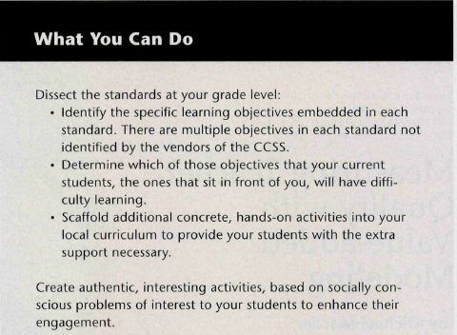
Susan Jenkins and Joachim Jack Agamba, authors of The Missing Link in the CCSS Initiative: Professional Development for Implementation, state that “Fundamentally, the CCSS identify what should be taught (learning objectives), not how the standards should be taught (methods and curriculum). Therefore, higher education must be retained to partner in building a step-wise, incremental process for unpacking (deconstructing the CCSS into teachable objectives) and implementing (designing supports for instructional practice) these research-based, internationally benchmarked, and rigorous mandates” (Jenkins & Agamba, 2013). Teachers need support with how to read the new standards and in determining the content that needs to be taught. Also, because of the change in the standards, new curriculum materials and resources have to be gathered for use during instruction in the classroom. Jenkins and Agamba call for not simply professional development to be implemented, but well-designed professional development (Jenkins & Agamba, 2013). They believe that professional development for teachers should “focus on helping teachers determine that they are teaching what they are supposed to be teaching, and students are learning what they are supposed to be learning” (Jenkins & Agamba, 2013). The following table indicates feature of effective professional development meetings for teachers. (Jenkins & Agamba, 2013)
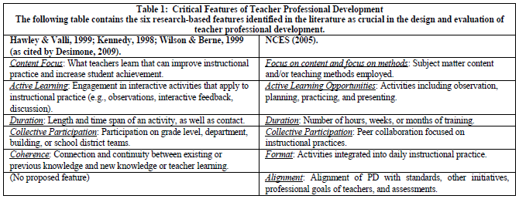Professional development for teachers is to ensure that they understand what needs to be taught to students. It is up to the teacher on how it should be taught. Everything teachers do inside and outside of the classroom in preparation for instruction should be to help students learn and understand the material, it should also be to help improve their learning. Jenkins and Agamba state that “Teacher professional development programs aim to improve student learning” and that effective professional development is the key (Jenkins & Agamba, 2013). Erik Robelen declared, in his blog “Math Teachers Find Common Core More Rigorous Than Their States”, that “most teachers reported receiving fewer than 20 hours of professional development over the past year related to the common core, according to findings from a joint project among researchers at several universities supported by a grant from the National Science Foundation” (Robelen, 2013). For teachers to be effective instruments in the classroom, they have to have effective professional development.
One benefit of the Common Core State Standards is that they are common to all of the states in the United States that have adopted them as their standards. This provides the opportunity for teachers to gather resources from other teachers in the entire country. These resources could be activity sheets, quizzes, assessments (tests, project ideas), online resources and many more. This component of the Common Core State Standards will benefit the teachers when they are designing lesson to instruct new content. It will give them a database of material from which to pull. Schmidt and Burroughs believe that these ‘common’ standards “should also reduce variation in content coverage within states, giving all administrators and educators much stronger incentives to ensure that all students have equitable opportunities to learn mathematics” (Schmidt & Burroughs, 2013).
The Center on Education Policy reports “that these standards are more rigorous than their previous standards in either English language arts or math and will improve students’ skills in these subjects” (Kober & Rentner, 2012). The rigor of the Common Core State Standards will provide students with essential critical thinking skills. Erik Robelen found that “More than 85 percent said the common-core math standards were more rigorous than their state's” (Robelen, 2013). Even though states believe that the Common Core State Standards are more rigorous than the previous standards that were implemented, they feel that these new standards will improve and increase student learning and achievement (Kober & Rentner, 2012). The figure below displays the results of a survey given by the Center on Education Policy regarding the rigor of the Common Core State Standards in math and English/language arts.

Implementation of the Common Core State Standards has been a hard and long process because of the rigor and complexity of the standards. Each subject has a specific number of standards that has to be covered in each grade. Therefore, time is another issue when implementing the new Common Core State Standards. There are numerous standards that teachers have to cover before the state-mandated assessment near the end of the school year. Andrew Ujifusa stated in his blog that “Challenges include getting trained professionals to administer the evaluation systems, recasting teacher certification and professional development, and finding more reliable measures of teacher performance, Minnici said” (Ujifusa, 2013). Assessment is a challenge that needs to be resolved before full implementation of the standards.
Another struggle that may arise when fully implementing the Common Core State Standards concerns the use of technology. Some states worry that there will be issues when using technology to assess students on these new standards. A few of these worries are internet access, bandwidth, and enough computers for each student to take the test at the same time (Kober & Rentner, 2012). A portion of the new assessment is a short answer section. Therefore, another concern is on how short answer questions will be given while utilizing the technology as the assessment tool.
Just as assessment is an issue for education, this same issue occurs with the Common Core State Standards. The nation and state education systems have to determine how to assess the students based upon these new standards. Christopher Tienken believes that there is a “lack of empirical evidence to support the CCSS and national testing” (Tienken, 2012). Tienken also stated in The Common Core State Standards: The Emperor is Still Looking for His Clothes” that “It is dangerously naïve and professionally irresponsible to think that one set of standards based solely on two subjects, can prepare children to access the thousands of college option or even make them attractive to the admissions officers that control access to those options” (Tienken, 2012). These standards were created and designed to help students develop the skills they need in order to be successful past high school. The Common Core State Standards was initiated to get students college and career ready. However, there is little evidence to show if these new standards will be successful in this goal.
Once a new assessment tool is created to determine the understanding the students have of the content based on the Common Core State Standards, students will have to adjust to a new way of testing; which will undoubtedly have effects on student performance as well. Robert Rothman asserts that “The consortia’s plans state that the results from the assessments will indicate whether students are on track for college and career readiness. But for those plans to be realized, higher education institutions must be engaged to validate that the assessments actually measure readiness” (Rothman, 2013). Not only is it the secondary schools job (including teachers) to prepare students for college, the colleges have to acknowledge these standards hold true to what they believe students should know upon entering college. The following table, from Plans to Adopt and Implement Common Core State Standards in the Southeast Region States, displays the timeline of the new assessment being finalized and which states are participating. Since, this article was written, Georgia has opted to not use the PARRC exam. (Anderson, Harrison & Lewis, 2012)
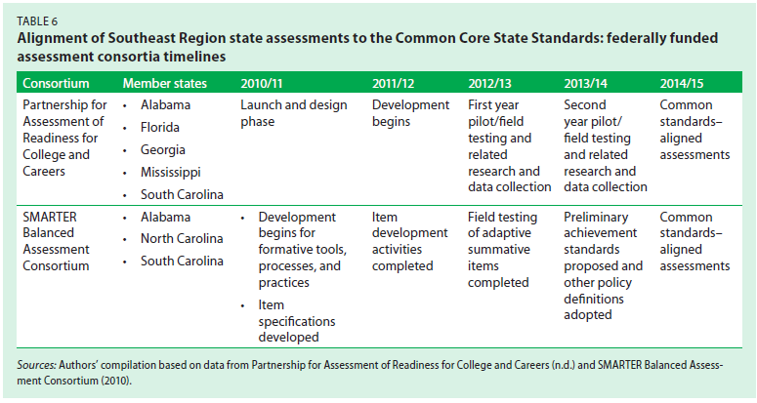
Not only are the teachers feeling the pressure and stress of the new standards, so are the students. They have been impacted by the topics in mathematics and English/language arts in that topics have moved to different grades. The students are also feeling the pressure and rigor of these new standards. These standards have the students think more critically and use real-world application skills. Schmidt and Burroughs, authors of Springing to Life: How Greater Educational Equality Could Grow From the Common Core Mathematics Standards, believe that these new standards can create a more equitable education for all students (2013). They think that the Common Core State Standards will give each student the same opportunities. Schmidt and Burroughs state that “In principle, every student ought to have the same opportunity to learn challenging mathematics content, but in schools, the content of instruction varies tremendously” (Schmidt & Burroughs, 2013). Robert Rothman believes “for the first time, the expectations are the same for almost all students, regardless of where they live. These standards represent a great opportunity to advance equity and excellence.” The Common Core State Standards level the playing field for all students.
The Common Core State Standards are not yet fully implemented in the adopted states. As stated earlier full implementation will most likely occur in the 2014-2015 school year. The questions and concerns that states still have regarding these standards also needs to be resolved before full implementation occurs. Additionally, the question of how will states assess the students based on these new standards needs to be addressed: will each state create their own test, will there be a national assessment? Many states planned to employ the use of the PARCC assessment as the new national assessment for students. PARCC stands for Partnership for Assessment of Readiness for College and Careers (Capelouto, 2013). Georgia, however, has pulled out of using this assessment because of funding concerns and technology availability for each student.
Overall, standards are necessary in the education world. They inform teachers of the information that needs to be taught in certain grades. Standards also state what students should have an understanding of by the end of the school year. The Common Core State Standards do not convey to teachers how to teach, but what to teach. Teachers still have the ability to make learning fun and creative. As teachers, we cannot let standards rule the classroom, but only guide our teaching. Educational standards for teachers and students will continue to exist and evolve for as long as education itself exists.

References

Achieve. (2013). The next generation science standards. Retrieved from http://www.nextgenscience.org/next-generation-science-standards
(Achieve, 2013, 1)

Achieve. (2013). Georgia. Retrieved from http://www.nextgenscience.org/georgia
(Achieve, 2013, 2)

Anderson , K., Harrison, T., & Lewis , K. (2012). Plans to adopt and implement common core state standards in the southeast region states. Regional Educational Laboratory, (136), A-27.

Barton, P. (2009, June). National education standards getting beneath the surface. Retrieved from http://www.ets.org/Media/Research/pdf/PICNATEDSTAND.pdf

Capelouto, S. (Writer) (2013, July 25). NPR. Georgia The Latest State To Back Out Of K-12 PARCC Tests. [Audio podcast]. Retrieved from http://www.npr.org/templates/story/story.php?storyId=205548324

Common Core State Standards Initiative. (2012).Implementing the common core state standards. Retrieved from http://www.corestandards.org/
(Common Core State Standards Initiative, 2012, 1)

Common Core State Standards Initiative. (2012). In the states. Retrieved from http://www.corestandards.org/in-the-states
(Common Core State Standards Initiative, 2012, 2)

Ga Department of Education. (n.d.). Georgia performance standards. Retrieved from https://www.georgiastandards.org/standards/Pages/BrowseStandards/BrowseGPS.aspx
(Ga Department of Education 1)

Ga Department of Education. (n.d.). Ccgps. Retrieved from https://www.georgiastandards.org/Common-Core/Pages/default.aspx
(Ga Department of Education 2)

Google. (n.d.). Standard. Retrieved from https://www.google.com/

Jenkins, S., & Agamba, J. (2013). The missing link in the ccss initiative: Professional development for implementation. Academy of Educational Leadership Journal, 17(2), 69-79.

Kober, N., & Rentner, D. Center on Education Policy, (2012). Year two of implementing the common core state standards: states’ progress and challenges. Retrieved from website: http://www.cep-dc.org/displayDocument.cfm?DocumentID=391

National Council of Teachers of Mathematics. (2013).Math standards and expectations. Retrieved from http://www.nctm.org/standards/content.aspx?id=4294967312

Robelen, E. (2013, August 07). [Web log message]. Retrieved from www.edweek.org

Rothman, R. (2013). A common core of readiness.Educational Leadership, 10-15.

Schmidt, W. H., & Burroughs, N. A. (2013). Springing to life: how greater educational equality could grow from the common core mathematics standards. American Educator, 2-9.

Tienken, C. (2012). The common core state standards: The emperor is still looking for his clothes. For the Record, (48), 152-155.

Ujifusa, A. (2013, August 07). [Web log message]. Retrieved from www.edweek.org

U.S. Department of Education. (n.d.). Definitions. Retrieved from http://www.ed.gov/race-top/district-competition/definitions

