Views of Struggling Students on Instruction Incorporating Multiple Strategies in Algebra I: An Exploratory Study
Author(s): Kathleen Lynch and Jon R. Star
Source: Journal for Research in Mathematics Education, Vol. 45, No. 1 (January 2014), pp. 6-
18
Published by: National Council of Teachers of Mathematics
Stable URL: http://www.jstor.org/stable/10.5951/jresematheduc.45.1.0006
Accessed: 05/11/2014 08:44

Your use of the JSTOR archive indicates your acceptance of the Terms & Conditions of Use, available at http://www.jstor.org/page/info/about/policies/terms.jsp

JSTOR is a not-for-profit service that helps scholars, researchers, and students discover, use, and build upon a wide range of content in a trusted digital archive. We use information technology and tools to increase productivity and facilitate new forms of scholarship. For more information about JSTOR, please contact support@jstor.org.

National Council of Teachers of Mathematics is collaborating with JSTOR to digitize, preserve and extend access to Journal for Research in Mathematics Education.

http://www.jstor.org

This content downloaded from 128.192.24.39 on Wed, 5 Nov 2014 08:44:32 AM All use subject to JSTOR Terms and Conditions

Copyright © 2014 by the National Council of Teachers of Mathematics, Inc., www.nctm.org. All rights reserved. This material may not be copied or distributed electronically or in other formats without written permission from NCTM.

Brief Report

Views of Struggling Students on Instruction Incorporating Multiple Strategies in Algebra I: An Exploratory Study

Kathleen Lynch and Jon R. Star
Harvard Graduate School of Education

Although policy documents promote teaching students multiple strategies for solving mathematics problems, some practitioners and researchers argue struggling learners will be confused and overwhelmed by this instructional practice. In the current exploratory study, we explore how 6 struggling students viewed the practice of learning multiple strategies at the end of a yearlong algebra course that emphasized this practice. Interviews with these students indicated they preferred instruction with multiple strategies to their regular instruction, often noting it reduced their confusion. We discuss directions for future research emerging from this work.

Key words: Algebra and algebraic thinking; High school education; Middle school education; Multiple strategies

Recently, calls for “algebra for all” have pressured school districts to enroll students of all learning backgrounds in Algebra I, often as early as the seventh or eighth grade (Kilpatrick, 2009). It is also clear, however, that students with weaker preparation frequently struggle in algebra classrooms (Steele & Steele, 2003). As more students of diverse learning backgrounds enter Algebra I classrooms, the question of how to most effectively teach struggling algebra students has become increasingly important (Stein, Kaufman, Sherman, & Hillen, 2011).
One promising instructional approach with the potential to improve strug- gling students’ learning of algebra is the practice of comparing and discussing multiple solution strategies for mathematics problems. There is increasing evidence that this practice benefits students’ learning (e.g., Star & Rittle-Johnson,
2008). It is also recommended in many recent policy reports in the United States
(National Council of Teachers of Mathematics, 2006; National Research Council,
2001; Woodward et al., 2012), including the Common Core State Standards

Thanks to Courtney Pollack, Nataliia Perova, Kristie Newton, Bethany Rittle- Johnson, Christine Size, and Erin O’Connell for their assistance in data collection and analysis. This research is supported by a grant to the second author from the National Science Foundation (DRL-0814571). Any opinions, findings, and con- clusions or recommendations expressed in this material are those of the authors and do not necessarily reflect the views of the National Science Foundation.

(National Governors Association Center for Best Practices & Council of Chief
State School Officers, 2010).
Despite apparent professional consensus, debate continues about whether instruction with multiple strategies is beneficial to all students or only to high- achieving students. These doubts come primarily from the practitioner commu- nity, but they also have some support from researchers. For example, Silver, Ghousseini, Gosen, Charalambous, and Strawhun (2005) found many teachers believed exploring multiple strategies would be feasible only with high-ability students. In addition, some researchers in special education advocate the presen- tation of a limited range of solution strategies (Montague, 1992; Scheuermann, Deshler, & Schumaker, 2009), perhaps due to a perception that the cognitive load of a multiple-strategies approach may overwhelm struggling students (e.g., Baxter, Woodward, & Olson, 2001; Baxter, Woodward, Voorhies, & Wong, 2002). Baxter, Woodward, and Olson (2001) noted some researchers in special education

view the discussion of alternative strategies and invented algorithms, a common approach in reform-based mathematics instruction, as problematic for low achievers because they believe multiple approaches to solving problems or even computing can only lead to confusion. These researchers see one simple set of rules as the best approach to teaching these students. (p. 530)

In this exploratory study, we consider the potential impact of instruction empha- sizing multiple strategies. The current findings emerged from a pilot study in which a small group of Algebra I teachers implemented new researcher-developed Algebra I curriculum materials emphasizing the comparison of multiple strat- egies. In this brief report, we describe our approach and highlight one element from our pilot work, the reactions of struggling students,1 that suggests to us the need for a closer look in future research at struggling algebra learners’ experiences with multiple strategies.
There is not unanimity in the field about what it means to teach mathematics with multiple strategies (Lynch & Star, in press). In particular, instruction incor- porating multiple strategies may include the following four implementation features. First, the problems used are often nonroutine (i.e., problems where an algorithm may not exist). Second, students generate or invent their own solutions to the nonroutine problems. Third, students have an opportunity to compare and contrast the multiple strategies, which may often involve the use of multiple repre- sentations such as symbols, tables, and graphs. And fourth, students and the teacher engage in a whole-class synthesis discussion around the multiple strate- gies. Similarly, the incorporation of multiple strategies can have at least two

1 Note that we do not consider the label “struggling” (as in struggling students) to be merely another way to refer to students with learning disabilities. Both the mathematics education and special education literatures point out that some (but not all) students with learning disabilities struggle in mathematics, and some (but not all) students who struggle in mathematics have learn- ing disabilities. However, there is a great deal of research within the field of special education on how to improve learning disabled students’ performance in mathematics, and this literature is very informative in our desire to learn more about how to assist struggling students in mathematics.

instructional goals. First, through discussion of multiple strategies, students will develop understanding of underlying and important mathematical concepts, the ability to connect between and among different representations, and under- standing of the rationale behind common algorithms. And second, students will know, are held accountable for, and are expected to subsequently use the discussed multiple strategies in future problem solving. These four features of multiple- strategy instruction, along with the two types of instructional goals, emerged from research around the learning and teaching of mathematics in elementary school, particularly the work of the Cognitively Guided Instruction (CGI) project (e.g. Car penter, Franke, Jacobs, Fennema, & Empson, 1998) combined with an emphasis on the use of multiple representations in algebra (e.g., Brenner et al.,
1997; Star & Rittle-Johnson, 2009b).
Although we adopt the label multiple-strategy instruction in the present work, our approach does not incorporate all four implementation features described above. In particular, instead of having students present and discuss their own invented solutions to nonroutine problems, the focus of our curriculum materials was to allow students to present and discuss already-worked pairs of routine problems, which were presented side-by-side to facilitate comparison and discussion of multiple contrasting cases. This approach has been used successfully in several prior studies (e.g., Rittle-Johnson & Star, 2007; Star & Rittle-Johnson, 2009a). In spite of the fact we do not incorporate two implementation features some may consider typical or even central to multiple-strategies instruction (student generation of strategies and use of nonroutine problems), we feel justified in using the phrase to describe our approach for three reasons. First, it is not unusual for teachers to introduce strategies not generated by students into a multiple-strategies discussion, such as when a teacher illustrates an alternative strategy with the introduction, “A student from another class solved the problem this way—what do you think of this approach?” Second, with our use of routine problems, the goals of our curriculum materials are well aligned with both of the instructional goals noted above. And finally, those concerned with the appropriateness of multiple-strategy instruction indicate it is the comparison of, discussion of, and expectation of subsequent use of multiple strategies that may overwhelm low achieving students (e.g., Baxter, Woodward, & Olson, 2001), rather than the invention of alternative strategies or the specific use of nonroutine problems.

Method

The curricular context for the present study is a set of researcher-designed instructional materials infusing multiple strategies into a yearlong Algebra I course. The materials feature the characters Alex and Morgan, who solve problems using multiple strategies. The curriculum materials used in the current inter- vention focused on the specific practice of comparing multiple strategies via students’ discussion of worked examples. More information about the curriculum materials can be found at http://scholar.harvard.edu/contrastingcases/ (see also Rittle-Johnson & Star, 2011).

Figures 1–3 show sample pages from our curriculum. In some example pairs (Figures 1 and 2), Alex and Morgan are solving the same problem but in two different ways. In some instances, the instructional goal of this type of comparison is for students to see and understand alternative ways of solving routine problems, as in Figure 1, where Alex and Morgan use two mathematically equivalent but (to students) very different strategies. In other instances, the goal is for students to understand conceptually why a common strategy works or why a typical error occurs. For example, in the pair of worked examples shown in Figure 2, where Alex and Morgan have different approaches for simplifying (62 )(52 ), the compar- ison of Alex’s and Morgan’s ways is intended to support a discussion that concep- tually unpacks what Morgan did and why it works. In other example pairs, Alex and Morgan solve two different problems but in similar ways. For example, in Figure 3, Alex graphed the equation y = 3x and Morgan graphed the equation y = 3x, with the goal of understanding how and why these functions, whose symbolic representation looks quite similar, result in tables and graphs that have very important differences. The 141 example pairs that were included in the complete curriculum covered the entire range of typical Algebra I content.
We developed a structured implementation model to accompany the written curriculum materials having three class discussion phases—Understand, Compare, and Make Connections. For each pair of worked examples, we provided ref lection prompts for each phase. In the Understand phase, prompts such as, “How did Morgan solve the equation?” were intended to establish student comprehension of each individual strategy. In the Compare phase, prompts such as, “What are some similarities and differences between Alex’s and Morgan’s ways?” were intended to guide students to compare the two strategies. The Understand and Compare phases were intended to prepare students for the final phase, Make Connections, in which prompts varied by the pair of worked examples and were intended to focus students’ discussion on the instructional goal of the comparison. Although the worked examples students compared were routine and frequently involved symbolic solution methods, the Make Connections phase was centrally concerned with understanding key algebraic principles. For example, in Figure 1, the discussion is launched through the questions at the bottom of the page; it is expected the teacher will use students’ answers to these questions to encourage consideration of why Alex’s and Morgan’s strategies work and what mathematical principles are brought to bear in each method. Similarly, in Figure 2, the Make Connections phase is focused on conceptually unpacking Morgan’s familiar strategy. Finally, in Figure 3, teachers were encouraged to push students toward understanding (via graphs, tables, and symbols) how and why linear and exponen- tial functions differ. In this exploratory study, teachers were given f lexibility in determining implementation details such as which examples to use in a class period and how much time to dedicate to each phase. For a more detailed discussion of the implementation model, see Rittle-Johnson and Star (2011).
The study was conducted in a large city in New England and its environs. Twelve middle and high school Algebra I teachers volunteered to participate in a weeklong

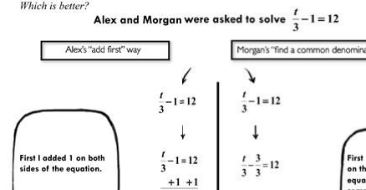
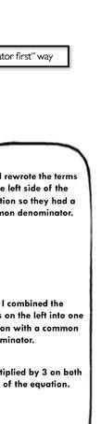
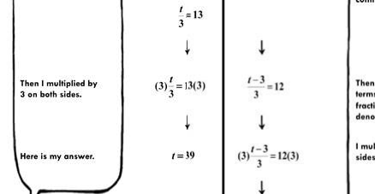
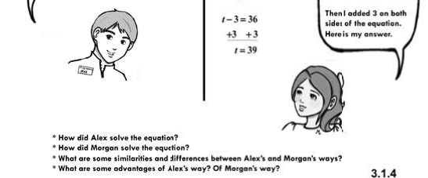
Figure 1. Example of a Which is better? worked example pair.

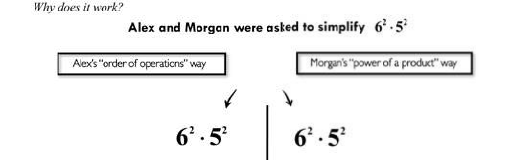
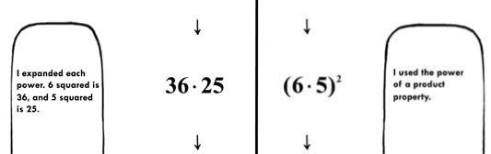
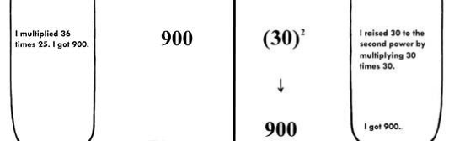
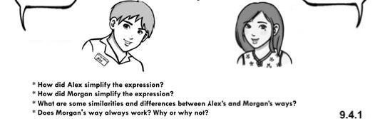
Figure 2. Example of a Why does it work? worked example pair.

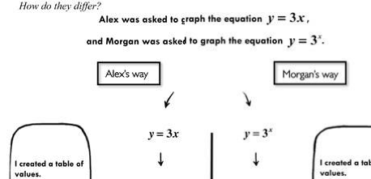
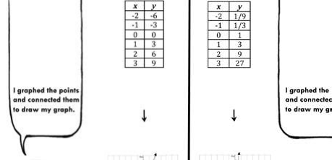
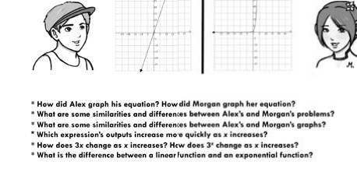
Figure 3. Example of a How do they differ? worked example pair.

institute on algebra teaching methods, where they were introduced to the curric- ulum materials as well as the structured implementation model described above. Teachers subsequently piloted the instructional materials during a yearlong Algebra I course.
At the end of the Algebra I course (late May), teachers were instructed to select interviewees who had a wide range of attitudes and experiences with respect to the researcher-designed intervention materials—some positive and some nega- tive. The 30-minute interviews were semistructured, exploring students’ experi- ences in the Algebra I course, par ticularly with multiple st rategies. See http://scholar.harvard.edu/contrastingcases/ for the interview protocol.
In total, we interviewed 23 students from 10 schools. Of these 23 students,
6 scored in the “low” band of a standardized algebra readiness test administered at the beginning of the year, indicating the students were unprepared for Algebra I and at an increased risk of subsequent low performance in the course. We targeted these 6 students’ interviews for analysis because of our interest in the experiences of struggling students. Keisha (9th percentile on the pretest) was in the eighth grade, whereas Mark (25th percentile), Gina (22nd percentile), Jordan (15th percentile), Isabel (1st percentile), and Nicole (1st percentile) were in the ninth grade.
Analysis of the inter views was conducted collaboratively, with multiple researchers engaging in coding and discussions (e.g., Lincoln & Guba, 1985). Although interviews touched on a range of topics, in this brief report we focus on students’ perceptions of the advantages and disadvantages of learning with multiple strategies. We examined each student’s complete interview for any refer- ences to advantages or disadvantages of learning with multiple strategies, both in questions specifically asked for perceptions of advantages and disadvantages as well as in all other sections of the interview. The unit of analysis was the conver- sational turn, or statement bounded by a shift in speakers (also referred to by some researchers as a move or utterance), which could be a statement, a question, or an answer (Johnstone, 2002). After developing initial categories relating to advan- tages and disadvantages, we reexamined the interviews for evidence that might challenge our categories, constantly comparing identified codes with the original data. We resolved all disagreements through discussion until we reached consensus.

Results

General Reactions to Instruction Using Multiple Strategies

Students generally appeared to find the emphasis on more than one way to solve an algebraic problem relatively novel; five of the six noted their previous teachers had infrequently or never emphasized this practice. To assess students’ general reactions, interviewers asked students what they thought about the focus on learning more than one way to solve problems. All of the students described multiple strategies as an improvement over “business as usual.” Several students

stated they enjoyed the multiple-strategy focus (N = 5). Learning multiple strategies had improved their understanding and alleviated their past difficulties (N = 4), improved their problem-solving success rate (N = 2), improved their attitudes toward mathematics (N = 1), and was thought provoking (N = 1).

Perceived Advantages

The most commonly cited advantage for multiple strategies, cited by all six of the students, was an increased awareness of different methods. Mark, for example, commented,

I thought it was better because it could like, open different ways of how to do the problems. So like one way could be the way that everybody else was doing, and it could be hard, but then with Alex and Morgan, you see a different way to do it, that could be easier.,

A second advantage, described by four students, was helping students find a method that “worked for them.” Gina, for example, stated,

I liked the multiple different ways, because the way some teachers have showed me in the past . . . they might’ve not worked for me as well. But then now because I’ve seen, like, a different way, I like, may possibly like another way better. And I’m a lot better at it.

Three students described multiple strategies as “easier” than learning one way; in a typical comment, Jordan stated,

Learning different ways of how to solve a problem was the best part. Because, there are some times where, there was only one way, I would have only learned one way, but then when you find a different way to do it, it’s so much easier to you.

Although many students spoke of affective advantages, two students more explicitly noted reduced anxiety about mathematics. For example, Keisha noted,

I think it’s great, because sometimes, people, they’re doing these kinds of problems, and they don’t understand how to do them, but then if you’re shown another way, and you’re shown to do it better, and it’s just, it can take relief off of some people. And I know it did for me.

In addition, students noted multiple strategies could improve accuracy (N = 2), provide a “back-up” method (N = 1), facilitate checking answers (N = 1), and help differentiate correct approaches (N = 1). Isabel, who had also stated the materials helped her to understand the steps to solve different equations, addi- tionally alluded to the relative efficiency of the strategies of Alex and Morgan:

Yeah, it helps, because instead of just using one strategy that’s like, the longest, some- times you would see that Alex was using a shorter way, or Morgan did. So I sometimes would use both ways, to like, solving an equation. It was cool, because I got to use the shorter way, which was much faster.

Perceived Disadvantages

Compared with the advantages, students cited disadvantages less frequently. Four students stated for them, there were no disadvantages to this approach. In a typical comment, Mark stated, “Nothing, really. I thought it was, like, I thought it was helpful.” Three students made reference to the possibility of confusion at some point in the interviews. One student, Nicole, who stated she had not experienced any disadvantages from learning with multiple strategies, mentioned her teacher had used specific techniques when introducing multiple strategies “so we’re not confused,” including instructing the class to first look over Alex and Morgan’s solutions and then to read Alex and Morgan’s narrations of their steps. Two students, Jordan and Keisha, referenced confusion as a possibility for them more directly. For example, Keisha noted “the disadvan- tages would be the other problem confusing you, and you not knowing which one to use or if that one’s correct or not.” Keisha also commented, however, this had never happened to her because she was able to identify methods she was successful with and discard others.
Overall, what stands out about these comments is that although the risk of confu- sion appears real, students described their worries about confusion more sporad- ically and less forcefully than they described their appreciation of multiple strate- gies. Indeed, all of the students in the current sample said there were more advantages than disadvantages to learning more than one way to solve a problem.

Discussion

Mathematics instruction using multiple strategies appeared to be a novel expe- rience for the six struggling students in the current sample. Despite its novelty, these six struggling students had quite positive perceptions of learning with multiple strategies, a view running counter to the perceptions of teachers in prior studies (e.g., Silver, Ghousseini, Gosen, Charalambous, & Strawhun, 2005) and those of some researchers (e.g., Baxter et al., 2002). Concerns about overwhelming struggling students were largely not substantiated among the students we inter- viewed. In fact, these six students cited the advantage of improved understanding and reduced anxiety repeatedly throughout the interviews. Also contrary to what might have been expected, these six struggling students cited relatively few disad- vantages to learning multiple strategies and felt that the risk of confusion was relatively minor.
How can we explain this disconnect between some teachers’ concerns about multiple strategies for struggling students generally and these six struggling students’ own expressed enthusiasm for this practice after a year of engaging with it? Although our current data do not address this question specifically, we speculate perhaps some teachers’ hesitation may be rooted in their own real prior experiences with attempting to present multiple strategies to struggling learners with unsuccessful results. In this context, we speculate perhaps the specific

structural components of the current intervention and its implementation may have contributed to its greater success in reaching these six struggling students—in other words, the how of implementing multiple-strategies instruction mattered a great deal.
In particular, the current intervention was carefully designed to maximize the likelihood students would reap the benefits of multiple strategies, while reducing the likelihood of overload. In particular, our approach incorporated the following components: (a) already worked examples; (b) carefully selected routine examples to be compared (such that the compared examples did not vary across too many dimensions, but rather were mostly similar, so that elements of differ- ences could be easily identified); (c) engaging cartoon characters; (d) explicit, step-by-step presentation of worked examples in both words (via dialogue bubbles) and mathematics syntax; and (e) a structured implementation model that gave guidance to teachers on ways to compare, contrast, and discuss multiple strategies conceptually and procedurally without overloading students. Certainly teachers’ concerns about overloading students are important and valid. Without careful consideration of how to teach with multiple strategies, including keen attention to both selection of examples to be compared and to presentation structure, students may indeed become confused. Our results suggest, however, with these elements, even struggling students may benefit from this instructional approach. The current study is exploratory in nature and has multiple limitations. First, we used a small convenience sample of volunteer teachers and as such, their adher- ence to the curriculum developers’ intended implementation model may have been unusually strong. Second, teachers selected students to be interviewed. Although teachers were instructed to select interviewees with a wide range of attitudes about the materials, we have no way to know whether this was indeed the case. Third, the students were aware the interviewers were members of the research group creating the materials. As a result, one might speculate the students wished to please the researchers and say only positive things about the curriculum. However, we suspect such an effect was relatively minor; students appeared relatively uninhibited in their critiques of some elements of the intervention. Finally, our small sample clearly limits our ability to generalize the present
findings.

Conclusions and Future Research Directions

Contrary to what might have been expected from the existing literature, the six struggling students in the current study described positive experiences from learning algebra with a multiple-strategies approach. We suggest the current findings may present a form of existence proof of the conception that under ideal circumstances, and with carefully designed curriculum materials, struggling students can emerge from a yearlong algebra course infused with multiple strate- gies with positive views of this approach, preferring it to their regular instruction. Although the current findings are exploratory in nature and not argued to be representative of struggling algebra learners broadly, our results suggest it may

be productive to revisit the question of whether and how struggling students should be exposed to multiple strategies. In particular, future studies could examine classrooms where teachers use a multiple-strategies approach to parse which elements of instruction and curriculum may best support struggling learners. In addition, future, larger studies should include student assessments of both proce- dural and conceptual algebra knowledge in order to evaluate the effectiveness of instruction with multiple strategies on a larger scale. Future research should also systematically measure teachers’ fidelity of implementation in order to explore the critical consideration of whether the curriculum was taught consistently or modified across classrooms. An additional promising direction for future research is an extension of the current curriculum materials to include a broader array of problem types, including nonroutine problems for which there is no defined or specific solution algorithm or pathway. Our efforts to explore these avenues for future research are currently underway.
Given the critical need to improve algebra instruction for this growing popula- tion, we hope the current exploratory findings might prompt future research to explore struggling algebra students’ engagement with multiple strategies in greater depth.

References
Baxter, J., Woodward, J., & Olson, D. (2001). Effects of reform-based mathematics instruction in five
third-grade classrooms. Elementary School Journal, 101(5), 529–548. doi:10.1086/499686
Baxter, J., Woodward, J., Voorhies, J., & Wong, J. (2002). We talk about it, but do they get it? Learning
Disabilities Research & Practice, 17(3), 173–185.
Brenner, M. E., Mayer, R. E., Moseley, B., Brar, T., Duran, R., Reed, B. S., & Webb, D. (1997). Learning by understanding: The role of multiple representations in learning algebra. American Educational Research Journal, 34(4), 663–689.
Carpenter, T. P., Franke, M. L., Jacobs, V. R., Fennema, E., & Empson, S. B. (1998). A longitudinal study of invention and understanding in children’s multidigit addition and subtraction. Journal for Research in Mathematics Education, 29(1), 3–20.
Johnstone, B. (2002). Discourse analysis (2nd ed.). Malden, MA: Blackwell.
Kilpatrick, J. (2009). Algebra is symbolic. In S. L. Swars, D. W. Stinson, & S. Lemons-Smith (Eds.), Proceedings of the 31st Annual Meeting of the North American Chapter of the International Group for the Psychology of Mathematics Education (Vol. 5, pp. 11–21). Atlanta, GA: Georgia State Uni- versity.
Lincoln, Y. S., & Guba, E. G. (1985). Naturalistic inquiry. Beverly Hills, CA: Sage.
Lynch, K., & Star, J. R. (in press). Teachers’ views about multiple strategies in middle and high school mathematics: Perceived advantages, disadvantages, and reported instructional practices. Mathe- matical Thinking and Learning.
Montague, M. (1992). The effects of cognitive and metacognitive strategy instruction on the math- ematical problem solving of middle school students with learning disabilities. Journal of Learning Disabilities, 25(4), 230–248.
National Council of Teachers of Mathematics. (2006). Curriculum focal points for prekindergarten through grade 8 mathematics. Reston, VA: Author.
National Governors Association Center for Best Practices & Council of Chief State School Officers. (2010). Common core state standards for mathematics. Retrieved from http://www.corestandards. org/assets/CCSSI_Math_Standards.pdf
National Research Council. (2001). Adding it up: Helping children learn mathematics. Washington, DC: National Academy Press.

Rittle-Johnson, B., & Star, J. (2007). Does comparing solution methods facilitate conceptual and pro- cedural knowledge? An experimental study on learning to solve equations. Journal of Educational Psychology, 99(3), 561–574.
Rittle-Johnson, B., & Star, J. R. (2011). The power of comparison in learning and instruction: Learning outcomes supported by different types of comparisons. In J. P. Mestre & B. H. Ross (Eds.), Psychol- ogy of Learning and Motivation: Cognition in Education (Vol. 55, pp. 199–222). Waltham, MA: Elsevier. doi:10.1016/B978-0-12-387691-1.00007-7
Scheuermann, A. M., Deshler, D. D., & Schumaker, J. B. (2009). The effects of the explicit inquiry routine on the performance of students with learning disabilities on one-variable equations. Learn- ing Disability Quarterly, 32(2), 103–120.
Silver, E. A., Ghousseini, H., Gosen, D., Charalambous, C., & Strawhun, B. (2005). Moving from rhetoric to praxis: Issues faced by teachers in having students consider multiple solutions for prob- lems in the mathematics classroom. Journal of Mathematical Behavior, 24, 287–301.
Star, J. R., & Rittle-Johnson, B. (2008). Flexibility in problem solving: The case of equation solving.
Learning and Instruction, 18, 565–579.
Star, J. R., & Rittle-Johnson, B. (2009a). It pays to compare: An experimental study on computa- tional estimation. Journal of Experimental Child Psychology, 102(4), 408–426. doi:10.1016/j. jecp.2008.11.004
Star, J. R., & Rittle-Johnson, B. (2009b). Making algebra work: Instructional strategies that deepen student understanding, within and between representations. ERS Spectrum, 27(2), 11–18.
Steele, M. M., & Steele, J. W. (2003). Teaching algebra to students with learning disabilities. Math- ematics Teacher, 96(9), 622–624.
Stein, M. K., Kaufman, J. H., Sherman, M. & Hillen, A. (2011). Algebra: A challenge at the crossroads of policy and practice. Review of Educational Research, 81(4), 453–492.
Woodward, J., Beckmann, S., Driscoll, M., Franke, M. L., Herzig, P., Jitendra, A. K., . . . Ogbuehi, P. (2012). Improving mathematical problem solving in grades 4 to 8: A practice guide (NCEE
2012-4055). Washington, D.C.: National Center for Education Evaluation and Regional Assistance, Institute of Education Sciences, U.S. Department of Education. Retrieved from http://ies.ed.gov/ ncee/wwc/pdf/practice_guides/mps_pg_052212.pdf

Authors
Kathleen Lynch, Harvard Graduate School of Education, Harvard University, 211 Longfellow Hall,
13 Appian Way, Cambridge, MA, 02138; kathleen_lynch@mail.harvard.edu
Jon R. Star, Harvard Graduate School of Education, Harvard University, 442 Gutman Library, 6
Appian Way, Cambridge, MA, 02138; jon_star@harvard.edu

Submitted December 11, 2012

Accepted April 4, 2013

