Plateau Patchnose Snake (a.k.a. Mountain Patchnose Snake)

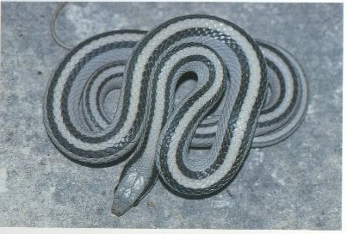

The symmetry of this snake is ITRVHG.

