MAC-CPTM Situations Project
Situation 10: Simultaneous Equations
Prepared at University of Georgia
13 April 2006 – Dennis Hembree and Erik Tillema
Edited at Penn State University
04 February 2007 – Evan McClintock

13 February 2007 – Rose Zbiek

26 March 2007 – Heather Godine

13 April 2007 – Pat Wilson

28 April 2007 – Jim Wilson, Heather Godine, Pat Wilson
15 May 2007 – Jim Wilson, Heather Godine, Pat Wilson

Prompt
A student teacher in a course titled Advanced Algebra/Trigonometry presented several examples of solving systems of three equations in three unknowns algebraically using the method of elimination (linear combinations). She started another example and had written the following
when a student asked, “What if you only have two equations?”

Commentary
Knowing necessary and sufficient conditions for unique solutions to systems of linear equations is important in this situation. The foci build from systems of equations in two variables to systems of equations in three variables, and examine why n independent equations are necessary to produce a unique solution to a system of equations in n variables. Systems of linear equations in two or three variables may be consistent or inconsistent and dependent or independent. If a system of linear equations is inconsistent, the equations will have no solutions in common. If a system of linear equations is independent, not all solutions for one equation are solutions for all of the other equations in the set. The foci use physical models, symbolic representations, graphical representations, and matrix representations to examine systems of linear equations with unique solutions, infinite solutions, and no solutions.

Mathematical Foci

Mathematical Focus 1

Solutions to equations are invariant under linear combinations.
If two equations in two variables x and y,
ax + by + c = 0 and dx + ey + f = 0
are in a linear combination
A(ax + by + c) + B(dx + ey + f) = 0
then any point (x, y) that satisfies the original equations will satisfy the linear combination. Similarly, for a linear combination of two equations in three variables, any solution (x, y, z) to the original equations will also satisfy the linear combination.
Thus, if one of the two equations is replaced by a linear combination, the solution is the same; the solution is invariant.
The purpose of the following example is to provide an intuitive sense for why solutions to equations are invariant under linear transformations. The included example is similar to examples found in the ancient Chinese text Jiu Zhang Suanshu (JZSS) or The Nine Chapters of the Mathematical Arts and many early Babylonian mathematical texts.

Two ropes have different lengths, and the sum of their lengths is 10 meters. To measure the length of a 46-meter bamboo rod requires 3 lengths of the first rope and 7 lengths of the second rope. Determine the length of each rope.
Letting x represent the length of the first rope and y the length of the second rope, the sum of the lengths of the rope can be expressed symbolically as . Since many combinations of values for x and y satisfy this equation, this one equation does not supply enough information to find a unique solution.
A second equation is needed to determine a unique value for the length of each rope. Since measuring a 46-meter bamboo rod requires 3 lengths of the first rope and 7 lengths of the second rope, a relationship between the lengths of the first and second rope can be expressed symbolically as .
Using length models to represent the equations and :
Because the sum of one length of each rope is 10m, the sum of three lengths of each rope would be 30m. This relationship could be expressed symbolically with the equivalent equations and . Using length models to represent the equations and :
Since is equivalent to , we can express the lengths of each rope with the system of equations and . Using length models to represent the equations and :
By comparing the top rope with the bottom rope in each representation, four lengths of the second rope must equal 16 meters, and therefore one length of the second rope is 4 meters. Expressed symbolically:
Hence, a unique length for the first rope exists, namely 6 meters.

Mathematical Focus 2

Two equations with two variables will have a unique solution if they are consistent and independent.
A linear equation in two variables is the equation of a line in the plane and therefore has an unlimited number of solutions.
Two equations have a unique simultaneous solution if the lines they represent intersect and are not coincident. Such equations are consistent and independent.
and
There is no solution if the lines are parallel and not coincident. Such equations are inconsistent; they have no common solution.
x + y = 3 and x + y = 5
There are an unlimited number of solutions if the lines are coincident. Such equations are consistent but dependent; they have all solutions in common.
x + y = 3 and 2x + 2y = 6

Mathematical Focus 3

A system of two linear equations in three variables may be consistent or inconsistent. A system of three linear equations in three variables may have no solutions (i.e. inconsistent), an infinite number of solutions (i.e. consistent and dependent), or a unique solution (i.e. consistent and independent).
A graphical representation of the points whose coordinates satisfy a linear equation in three variables is a plane. A graphical representation of the solution of a system of two or three linear equations in three variables would be the intersection of the two or three planes representing the solutions of each of the three equations.
Two planes will either be parallel or intersecting, as illustrated in figures 1 and 2.
Figure 1: Two parallel planes Figure 2: Two intersecting planes
When two planes are parallel, as shown in Figure 1, and the system of two equations is inconsistent and has no solution. When the planes intersect in a line, as shown in figure 2, all the points on the line of intersection of the two planes are solutions and the system has infinitely many solutions, the equations are consistent but not independent. Without a third plane to intersect that line of intersection, there is no unique point of intersection. Thus, a system of two equations in three unknowns cannot have a unique solution.
The three planes represented by equations with three variables will either be parallel or can intersect in several ways, as illustrated in figures 3 through 7. The cases where two or more of the planes coincide are not shown here.
When all three planes coincide the equations are consistent but not independent. There are an infinite number of solutions. When two of the three planes coincide, the result is depicted in figure 1 (if the third plane is parallel) or in figure 2 (if the third plane intersects).
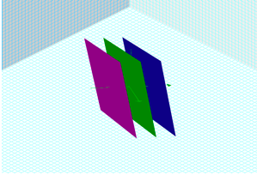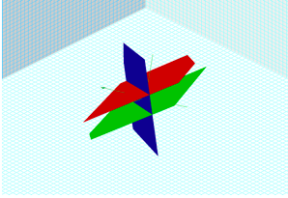
Figure 3: Three parallel planes Figure 4: Three planes,
two of which are parallel
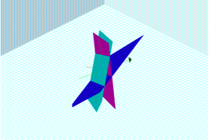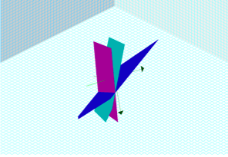
Figure 5: Three planes intersecting Figure 6: Three planes intersecting
pairwise in three parallel lines in a line

Figure 7: Three planes intersecting in a point

In figure 3, figure 4, and figure 5 the equations are inconsistent and thus no solutions; in figure 6 the equations are consistent but not independent and thus an infinite number of solutions; and in figure 6 the equations are consistent and independent and there is a unique solution.

Mathematical Focus 4

Systems of linear equations are often solved by matrix methods. Matrix methods can also be used to determine if equations are consistent or independent.
One technique involves multiplying the inverse of the coefficient matrix and the matrix of constants, in that order. The determinant of the coefficient matrix must be non-zero for the equations to be consistent and independent and thus have a unique solution.
In the case of a system of two equations with three unknowns, the 2x3 coefficient matrix is not a square matrix. Thus the coefficient matrix does not have an inverse and a unique solution does not exist. However, that does not necessarily mean that no solution exists.
If the system of two equations with three variables is consistent, finding a set of infinite solutions may be accomplished by performing Gaussian elimination on the augmented matrix of coefficients and constants. Consider the general case of a system of two equations in three variables:
Performing Gaussian elimination on the augmented matrix of coefficients and constants gives the augmented matrix:
, where are constants.
The augmented matrix represents an equivalent system of two equations in three variables:

or
These equations indicate that, although the values of x and y depend on the value of z, the value of z is arbitrary. Hence, a system of two equations in three variables may have many solutions.
This method or its matrix equivalent assumes that a₁b₂ – a₂b₁ , b₁c₂ – b₂c₁ , and a₁c₂ – a₂c₁ are not all equal to zero in order to have consistent equations.

