MAC-CPTM Situations Project

Situation 21: Exponential Rules

Prepared at University of Georgia
Center for Proficiency in Teaching Mathematics
29 June 2005 – Erik Tillema

Edited at University of Georgia
19 June 2006 – Sarah Donaldson
22 June 2006 – Sarah Donaldson
21 September 2006 – Sarah Donaldson
19 February 2007 – Kelly Edenfield

Edited Cross Sites
19 March 2007 -- Jim Wilson
5 April 2007 – Sarah Donaldson, Eileen Murray
13 April 2007 – Glen Blume

Edited at University of Georgia
17 April 2007 – Sarah Donaldson, Eileen Murray
10 May 2007 – Sarah Donaldson

Prompt

In an Algebra II class, students had just finished reviewing the rules for exponents. The teacher wrote 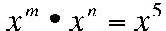 on the board and asked the students to make a list of values for m and n that made the statement true. After a few minutes, one student asked, “Can we write them all down? I keep thinking of more.”

Commentary

The relevant mathematics in this Situation reaches beyond the basic rules for exponents into issues of the domains of the variables in those rules. The exponent rule $x^{m}⋅x^{n}=x^{m+n}$ is applicable and is key to deciding how many solutions there will be. However, applying this rule beyond the usual context of positive bases and positive exponents to that of other number systems (such as the set of integers or rational numbers) requires consideration of the domains of the base and the exponents. In the following Foci, symbolic, numeric, and graphical representations are used to highlight that there are particular values in the domains of both x and m for which x^{m} is not a real number. In Foci 2 and 3, the domains of x and m are extended beyond the positive numbers and x^{m} is examined in these new domains.

Mathematical Foci

Mathematical Focus 1
Defining the domains of x and m clarifies the rule $x^{m}⋅x^{n}=x^{m+n}$ as applying to expressions with positive bases and real exponents.

The exponent rule $x^{m}⋅x^{n}=x^{m+n}$ may be applied to the equation $x^{m}⋅x^{n}=x^{5}$ if the value of x is restricted to positive numbers. That is, if $x>0$, and m and n are real numbers, then $x^{m}⋅x^{n}=x^{m+n}$.

If the values of m and n are restricted to natural (counting) numbers, then there is a finite number of solutions for (m,n): (1,4), (2,3), (3,2), and (4,1). If m and n are not restricted to the natural numbers, then there are infinitely many solutions for (m,n), since there are infinitely many solutions to the equation $m+n=5$. Thus, m and n could be any two values whose sum is 5.
The restriction $x>0$ is necessary if the value of each term in the equation is restricted to the set of real numbers. If, for example, $m=1\text{.}5$, then, . For this result to be a real number, x cannot be negative. Some restriction also may be necessary when x is zero, for example, if m=-1 and x=0, then$x^{m}$ is undefined.

Mathematical Focus 2
When the domain of x is extended to the negative real numbers or 0, then the domain of m is limited to those values for which x^{m} is defined.

If $x^{m}$ is to be a real number, then the value of x determines the domain for m. (All statements about $x^{m}$ also hold for $x^{n}$.) Specifically, if x and m are real numbers, then:
a. If $x=0$, then $m>0$. Note that $0$ raised to a negative power (e.g., $0^{−2}$) is undefined. In many cases, $0^{0}$ is considered to be indeterminate. However, there are instances (for example, in the Binomial Theorem) in which $0^{0}$ is defined as 1.
b. If $x>0$, then m could be any real number. This is what is assumed in the rule $x^{m}⋅x^{n}=x^{m+n}$ as noted in Focus 1.
c. If $x<0$, then x^{m} is defined only when m is a rational number (in lowest terms) whose denominator is odd.

Some examples may clarify point c. First, consider a subset of the rational numbers with odd denominators: the set of integers.
Let $x\text{=-}2$. With this (or any negative real number) as a base, the exponent, m, may be any integer and the result will be a real number:
m | $${\left(−2\right)}^{m}$$
-3 | -0.125
-2 | 0.25
-1 | -0.5
0 | 1
1 | -2
2 | 4
3 | -8

The exponent, m, may also be any rational number (in lowest terms) as long as its denominator is odd.
Consider the case when m is a rational number with an even denominator, such as ½; recall that the exponent now indicates an even root. An even root of a negative number yields an imaginary result. If we restrict the domains of x and m to the real numbers, then an even root of a negative number lies outside these domains. If $x^{m}$ were not limited to the domain of real numbers, then m could be any number as long as $x¹0$ (as explained in a. above).
Examining a list of values of ${\left(−2\right)}^{m}$and the resulting graph also provides insight into these restrictions. The following graph is the result of plotting the points in the table below. These points were chosen because they show that ${\left(−2\right)}^{m}$ is a real number for certain values of m and not for others. Notice that the values for m which result in ${\left(−2\right)}^{m}$ not being a real number (Ø) are those with decimals that, if written as fractions in lowest terms, would have even denominators. Notice also that the real values of ${\left(−2\right)}^{m}$ in the table alternate between positive and negative. This is because a negative base raised to an even power is positive (such as ${\left(−2\right)}^{−2}=0\text{.}\text{25}$), and a negative base raised to an odd power is negative (such as ${\left(−2\right)}^{−3}\text{=-}0\text{.}\text{125}$).

m | $${\left(−2\right)}^{m}$$ | m | $${\left(−2\right)}^{m}$$ | m | $${\left(−2\right)}^{m}$$ | m | $${\left(−2\right)}^{m}$$ | m | $${\left(−2\right)}^{m}$$
-3 | -0.125 | -2 | 0.25 | -1 | -0.5 | 0 | 1 | 1 | -2
-2.9 | Ø | -1.9 | Ø | -0.9 | Ø | 0.1 | Ø | 1.1 | Ø
-2.8 | 0.143… | -1.8 | -0.287… | -0.8 | 0.574… | 0.2 | -1.148… | 1.2 | 2.297…
-2.7 | Ø | -1.7 | Ø | -0.7 | Ø | 0.3 | Ø | 1.3 | Ø
-2.6 | -0.164… | -1.6 | 0.329… | -0.6 | -0.659… | 0.4 | 1.319… | 1.4 | -2.639…
-2.5 | Ø | -1.5 | Ø | -0.5 | Ø | 0.5 | Ø | 1.5 | Ø
-2.4 | 0.189… | -1.4 | -0.378… | -0.4 | 0.757… | 0.6 | -1.515… | 1.6 | 3.031…
-2.3 | Ø | -1.3 | Ø | -0.3 | Ø | 0.7 | Ø | 1.7 | Ø
-2.2 | -0.217… | -1.2 | 0.435… | -0.2 | -0.870… | 0.8 | 1.741 | 1.8 | -3.482…
-2.1 | Ø | -1.1 | Ø | -0.1 | Ø | 0.9 | Ø | 1.9 | Ø

With m on the horizontal axis and ${\left(−2\right)}^{m}$ on the vertical, the graph is:
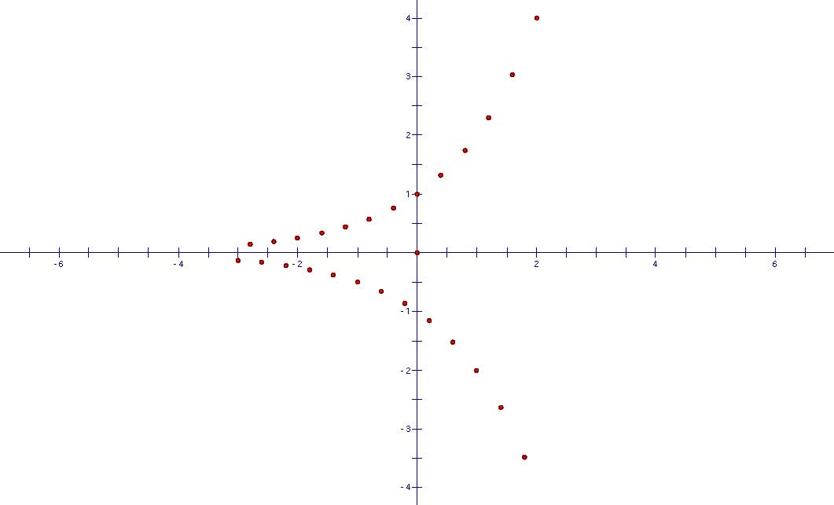

Mathematical Focus 3

If the domain of m is extended, then the domain of x is limited to those values for which x^{m} is defined.

Thus far we have concentrated on how the value of the base, x, in $x^{m}$determines the domain of the exponent, m. But it is also true that if $x^{m}$ is to be defined in the real numbers, then the value of m puts certain limitations on x. (Note, however, that we are still limiting our discussion to real values, and subsets of the reals, of x and m.)
- If m is a positive integer, then x may be any real number. For example, $x^{6}$ is always defined on the real numbers.
- If m is a non-zero rational number with an odd denominator (when written in lowest terms), then x may be any real number. For example, $x^{\frac{3}{5}}=\sqrt[5]{x^{3}}$ is always defined on the real numbers.
- If m is an integer and $m≤0$, then $x\text{ÎÂ},x¹0$. This is the contrapositive of a. in Focus 2.
- If m is an irrational number or a nonzero rational number (in lowest terms) with an even denominator, then $x³0$. (See previous discussion of even denominators.) This is the contrapositive of c. in Focus 2.

