MAC-CPTM Situations Project

Situation 08: Locus of a Point on a Moving Segment

**Prepared at Pennsylvania State University**

**Mid-Atlantic Center for Mathematics Teaching and Learning**

**18 June 2005 – Rose Mary Zbiek**

**Edited at University of Georgia**

**Center for Proficiency in Teaching Mathematics**

**13 June 2006 – Jim Wilson**

**Edited at Pennsylvania State University**

**Mid-Atlantic Center for Mathematics Teaching and Learning**

**22 October 2008 – Heather Godine**

**11 November 2008 – Heather Godine, Maureen Grady, and Svetlana Konnova**

**8 September 2009 – M. Kathleen Heid**

# Prompt

A high school geometry class was in the middle of a series of lessons on loci. The teacher chose to discuss one of the homework problems from the previous day’s assignment.

A student read the problem from the textbook (Brown, Jurgensen, & Jurgensen, 2000): *A ladder leans against a house. As A moves up or down on the wall, B moves along the ground. What path is followed by midpoint M? (Hint: Experiment with a meter stick, a wall, and the floor.)*

The teacher and two students conducted the experiment in front of the class, starting with a vertical “wall” and a horizontal “floor” and then marking several locations of M as the students moved the meter stick. The teacher connected the points. Their work produced the following data picture on the board:

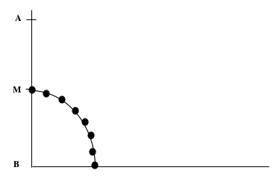

A student commented, “That’s a heck of an arc.”

# Commentary

The foci for this situation utilize a variety of models and representations of the locus. In the class demonstration, the data were generated using a physical model. In two foci the data have been generated using a dynamic geometry system. Other foci explore the situation from the standpoints of axiomatic geometry and coordinate geometry.

# Mathematical Foci

## Mathematical Focus 1

*Dynamical geometry environments can provide a powerful tool for investigating geometric relationships in coordinate geometry settings.*

We can create samples of data points using the Geometer’s Sketchpad (VIG M 050606 Ladder arc.gsp based on GSP provided file, Falling Ladder.gsp). To determine the path traveled by the midpoint of the ladder as it travels from the vertical to the horizontal position, first consider a point above the midpoint of the ladder. Using the marks for a point above the midpoint of the ladder when the ladder is vertical, horizontal and in three other positions, we create an elliptical arc that appears to pass through all of the other points. Since an elliptical arc through five or more points is unique, this suggests the path of a point above the midpoint is an elliptical arc.

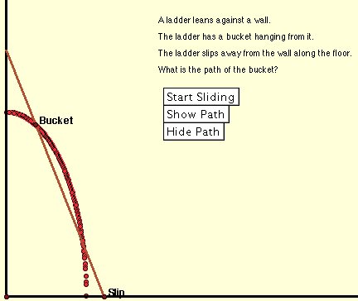

Now consider a point below the midpoint of the ladder. Using the marks for a point below the midpoint of the ladder when the ladder is vertical, horizontal and three other locations, we create an elliptical arc that appears to pass through all of the other points. Since an elliptical arc through five or more points is unique, this suggests the path of a point below the midpoint is an elliptical arc.

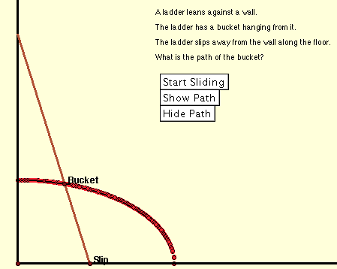

Now consider the paths created by points above and below the midpoint of the ladder as those points move closer to the midpoint of the ladder. Since the elliptical arcs would converge to an arc as the points moved closer to the midpoint of the ladder, this suggests that the path created by the midpoint of the ladder is an arc. Moreover, using the marks for midpoint of the ladder when it is vertical and horizontal and the midpoint when it is in one other location, we create a circular arc that appears to pass through all of the other points. Since a circular arc through three or more points is unique, this suggests that the path of the midpoint is a circular arc.

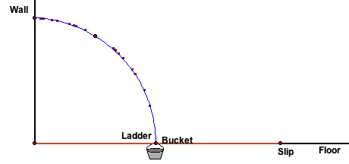

## Mathematical Focus 2

*If all the points on a continuous path lie on a circle then the path created is an arc of the circle.*

We create a sample of data points using the Geometer’s Sketchpad. Run the Falling Ladder.gsp simulation to create the path of the midpoint of the ladder. Construct a circle whose center lies on the intersection of the floor and wall (point B in the given sketch) and passes through the midpoint of the ladder when the ladder is vertical and when it is horizontal. Since all of the data points appear to lie on the circle and every data point from the midpoint of the ladder in its vertical position to the midpoint of the ladder in its horizontal position would form a continuous curve, the path is a circular arc.

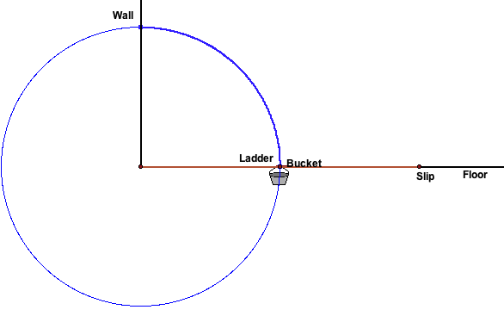

## Mathematical Focus 3

*When quantities in a situation can be graphed on a coordinate system, coordinate geometry can be used to write an equation that relates the x and y coordinates.*

The “Slip” (Point S) is at distance *2a* from O, the intersection of the floor and the wall. P is at distance *2b* from O. The length of the ladder is *2c*. Then the coordinates of S and P are (*2a*, 0) and (0, *2b*), respectively. The coordinates of M are (*a*, *b*).

Construct a line perpendicular to  from M. The point where that line intersects  is Q. ΔOPS~ΔQMS. So,  or . The coordinates of any point M satisfy the equation of a circle with radius *c* and center (0,0). That is, the coordinates of M are of the form (*m*1, *m*2) where . Since these coordinates could be any non-negative real numbers, the set of all possible points M would lie on an arc of the circle with center (0,0) and radius c that lies in the first quadrant. In addition, any point M is always equidistant from P, S, and O.

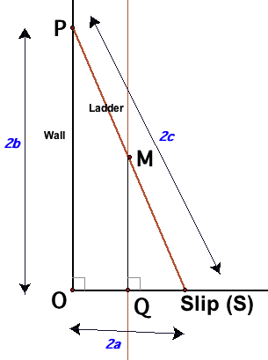

# *Mathematical Focus 4*

*The theorems and definitions of classical geometry can be used to demonstrate the locus of points is a circle.*

The physical situation of a ladder against the wall assumes that the ladder forms the hypotenuse of a right triangle and the legs of the right triangle lie along the wall and the ground at right angles:

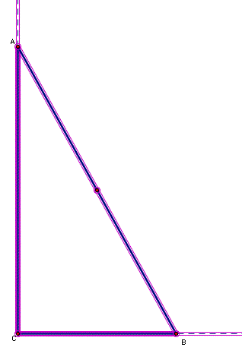

There is a general result about the midpoint of the hypotenuse of a right triangle that is a rather early theorem in Geometry:

THEOREM: The midpoint of the hypotenuse of a right triangle is equidistant from the three vertices of the triangle.

There are multiple elementary proofs of this theorem. However, the theorem would lead quickly to the following picture:

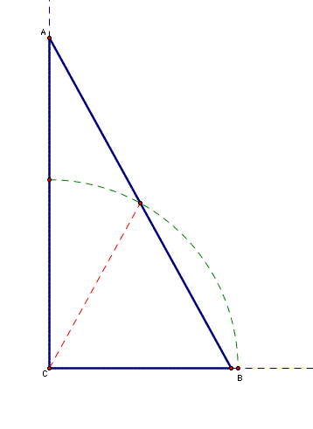

# That is, as the ladder moves, the legs of the right triangle change but the hypotenuse (the ladder) remains the same length and the distance of its midpoint from the center will stay the same. The locus of the midpoint then lies along the arc of a circle with radius determined by the distance of the midpoint of the hypotenuse from the right angle vertex.

# Mathematical Focus 5

*Modifying the problem slightly to allow the fixed point on the ladder to be someplace other than the midpoint, produces a locus of points that is an elliptical arc.*

Superimpose a rectangular coordinate system on the figure with the origin at the intersection of the wall and the ground. We can designate the coordinates of our fixed point as (x, y) and designate the distance from the top of ladder to our point as *a* and the distance from the bottom of the ladder to our point as *b.*

Because  is parallel to , and  is parallel to ,  and  By the Pythagorean Theorem, *m, so * which yields 



This is the equation of an ellipse with center at the origin and axes of length *2a* and *2b*. We can then examine the special case of our fixed point as the midpoint of the ladder which makes *a=b*. By substitution we find that the equation is now the equation of a circle with center at the origin and radius of *a*.

# Reference

Brown, Richard G., John W. Jurgensen, and Ray C. Jurgensen. *Geometry*. McDougal Littell, A Houghton Mifflin Company, Boston, MA: 2000. p. 405.