Appendix B

The example and the real-world application below, from the Glencoe-McGraw-Hill book, illustrate the following ideas in the Algebra Standard:
- Write equivalent forms of equations, inequalities, and systems of equations and solve them with fluency—mentally or with paper and pencil in simple cases and using technology in all cases
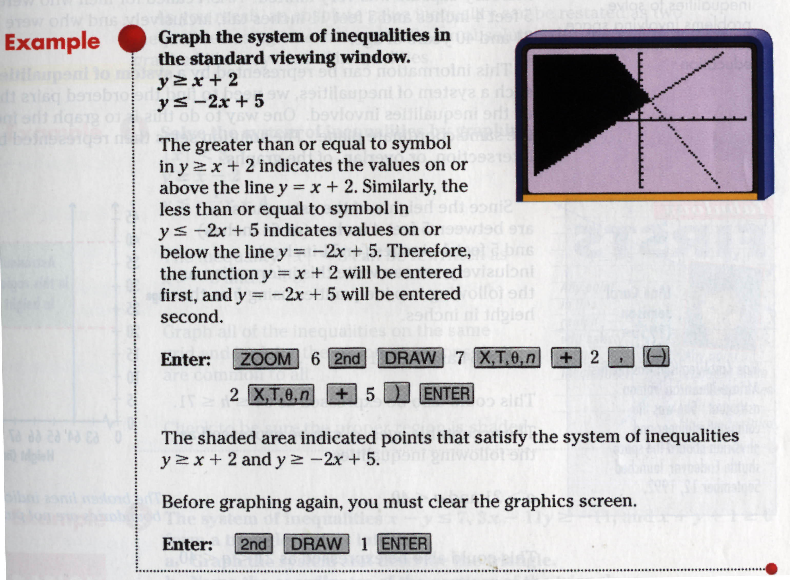

(Glencoe McGraw-Hill, 147)
- Understand the meaning of equivalent forms of expressions, equations, inequalities, and relations.
- Write equivalent forms of equations, inequalities, and systems of equations and solve them with fluency—mentally or with paper and pencil in simple cases and using technology in all cases.
- Use symbolic algebra to represent and explain mathematical relationships.
- Use a variety of symbolic representations, including recursive and parametric equations, for functions and relations.
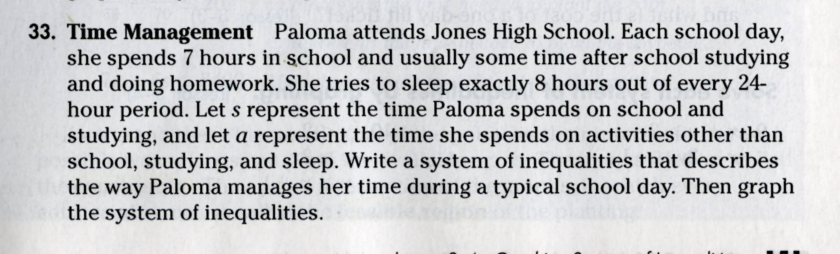

(Glencoe McGraw-Hill, 151)

