How Far Can You Move a Wall??

Nanotechnology is a field of science that studies objects and their relationships at the nanometer level. How small is a nanometer? If a nanometer were the size of a penny, then one foot would be the distance from Seattle to Miami! A nanometer is one billionth of a meter. With nanotechnology, new tools have to be developed that can measure incredibly small items and their movements. One way researchers do this is using a special microscope called an AFM (atomic force microscope). An AFM uses lasers and reflective surfaces to see what is happening at the nano-scale. In this experiment you will use a similar process involving a laser and mirror to determine if you can actually move a solid wall.

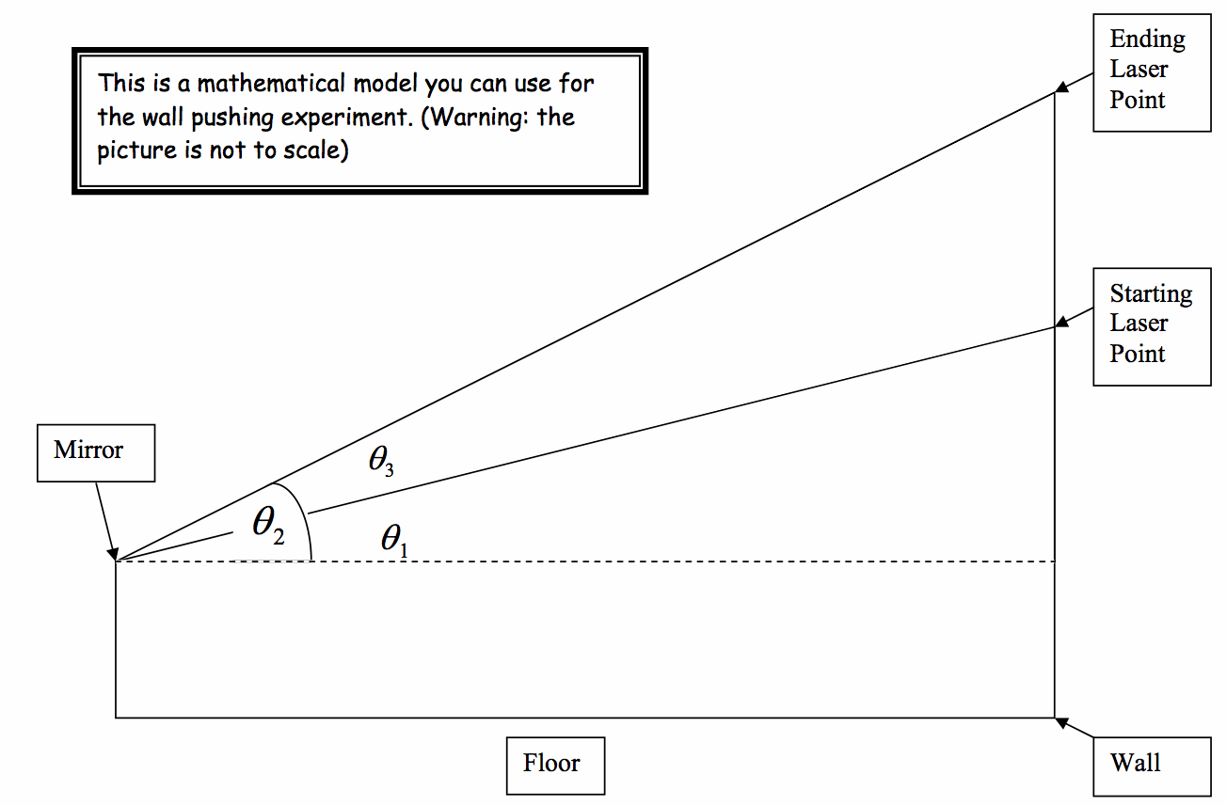

Step One: Record your measurements and label them in the diagram above.
Distance from the mirror to the wall:______________ Distance from the floor to the mirror:______________ Distance from the floor to the starting laser point:____________ Distance from the floor to your ending laser point:____________

Step Two: Use your knowledge of triangles and trigonometry to determine the number of degrees that the mirror turned.
- Which angle in the diagram represents the number of degrees the mirror turned?______Why?_________________________________________
- Find the measure of θ1
- Find the measure of θ 2
- Find the measure of θ 3

Step Three: Calculate the distance the wall moved!
- The diameter of the small pin attached to the mirror is .042 inches. Find the Circumference of that pin.__________________
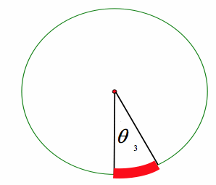
- The t-pin rolled a very small portion of its circumference. In mathematics, a part of a circumference is called an arc. The arc’s length is proportional to the number of degrees that the mirror turned. The diagram to the left illustrates a cross section of the t-pin. One complete revolution of the pin is 360 degrees. Use this information to write a proportion that will allow you to find the arc length the t-pin rolled. Write and solve your proportion here:

- Remember, the distance that the pin rolled is the same as the distance that the wall was pushed back. How far did you move the wall?______________

Step Four: Determine how small of a movement that really is!
- Convert the amount you moved the wall into meters. (Hint: To convert inches to meters, just multiply by .0254). Write the amount in meters you moved the wall:_____________.
- Use the scale below to determine which metric measurement would be best to describe the amount you moved the wall. Your Answer:_________________

