***Notes on the Riding on the Where’s the Identity Learning Task***

***This task wraps up the unit by introducing common techniques used in establishing more complex identities. Students often confuse establishing identities with solving equations, because students are so used to solving an equation when given one. It is important to make sure students understand that when asked to establish an identity, they are not solving an equation, and that with an identity, any value of a variable for which the expressions in the identity are defined will be a solution.***

***The first two problems address the common mistakes that can occur if students treat establishing identities as problems similar to solving equations. Students then are given three sets of identities to establish, with each set requiring the application of a specified group of the basic identities listed in standard MM4A5. This task is a culmination of previous units, as it requires knowledge of all identities learned in previous units.***

***This task addresses standard MM4A5.***

**establishing identities**

As you saw in *Where’s the Identity?*, trigonometric identities can be difficult to recognize, but by thinking graphically, numerically, and algebraically, you can gain valuable insight as to whether equations are identities or not. Numerical and graphical information is not enough to verify an identity, however.

Identities can be established algebraically by rewriting one side of the equation until it matches the expression on the other side of the equation. Rewriting is often done by applying a basic trigonometric identity, so the identities you have already established are listed here for reference.

|  |  |  |
| --- | --- | --- |
| **Quotient Identities** | **Reciprocal Identities** | |
|  |  |  |

|  |  |  |  |
| --- | --- | --- | --- |
| **Pythagorean Identities** | | | |
|  |  | |  |
| **Sum & Difference Identities** | | **Double Angle Identities** | |
|  | |  | |

When establishing identities, it is important that each equation that you write is logically equivalent to the equation that precedes it. One way to ensure that all of your equations are equivalent is to work with each side of the equation independently. The following problem provides an example of how failing to work with each side of an equation independently can produce what appears to be a proof of a statement that isn’t true. This example should serve as a reminder as to why you should work with each side of an equation independently when establishing identities.

1. As explained above, a helpful guideline when establishing identities is to change each side of the equation independently. Circle the two lines that were produced by failing to abide by this guideline, in the “faulty proof” below.









1. Explain why is not an identity, using either graphical or numerical reasoning.

***Solution: Making a table of values that shows numeric differences between the expressions of each side of the equation provides numerical reasoning as to why the equation is not an identity. Although some values of  may produce equal values, for the statement to be an identity, each side of the equation must be equal for all values of , which is not the case in this example:***

|  |  |  |
| --- | --- | --- |
|  |  |  |
|  |  |  |
| ***0*** | ***0*** | ***0*** |
|  |  |  |

***Graphing each side of the equation as a function provides graphical reasoning as to why the equation is not an identity:***

*** ***

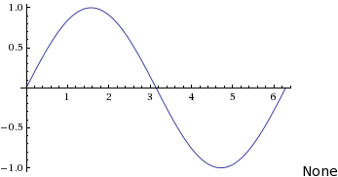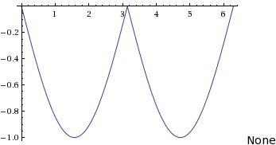

When establishing the following identities, keep the following two general rules of thumb in mind. They will not always lead to the most efficient solution, but they are usually beneficial when help is needed.

* Begin working on the most complex side, because it is usually easier to simplify an expression rather than make it more complex.
* When no other solution presents itself, rewrite both sides in terms of sines and cosines.

**Establish the following identities by rewriting the left, right, or both sides of the equation independently, until both sides are identical.**

For problems 3-5, apply either the quotient or reciprocal identities.

1. 

***Solution:***





1. 

***Solution:***





1. 

***Solution:***







For problems 6-10, apply the Pythagorean Identities.

1. 

***Solution:***





1. 

***Solution:***









***Solution:***









1. 

***Solution:***















1. 

***Solution:***







For problems 10-12, apply the sum, difference, or double angle identities.

1. 

***Solution:***









1. 

***Solution:***







1. 

***Solution:***











1. 

***Solution:***





