**Getting Started with Trigonometry and the Unit Circle Learning Task:**

An angle is in ***standard position*** when the vertex is at the origin and the initial side lies on the positive side of the x-axis.

The ray that forms the ***initial side*** of the angle is rotated around the origin with the resulting ray being called the ***terminal side*** of the angle.

An angle is ***positive*** when the location of the terminal side results from a counterclockwise rotation. An angle is ***negative*** when the location of the terminal side results from a clockwise rotation.



The two angles above are called ***coterminal*** because they are in standard position and share the same terminal side. Angles are also coterminal when they share terminal sides as the result of complete rotations. For example, 20 degree and 380 degree angles in standard position are coterminal.

1. Measure each of the angles below. Determine three coterminal angles for each of the angles.



a. b. c.

***Reference angles*** are the angle formed between the terminal side of an angle in standard position and the closest side of the x-axis. All reference angles measure between 0o and 90o.

|  |  |
| --- | --- |
| Quadrant I | Quadrant II |
|  |  |
| Quadrant III | Quadrant IV |
|  |  |

1. Determine the reference angle for each of the following positive angles.
   1. 300o __________ d. 210o __________
   2. 135o ________ e. 585o  __________

* 1. 30o ________ f. 870o  __________

1. Determine the reference angle for each of the following negative angles.
   1. -45o __________ d. -405o __________

* 1. -120o __________ e. -330o __________

* 1. -240o __________f. -1935o __________

***Angles as a Part of the Unit Circle***

1. The circle below is called the ***unit circle***. Why do you believe this is so?

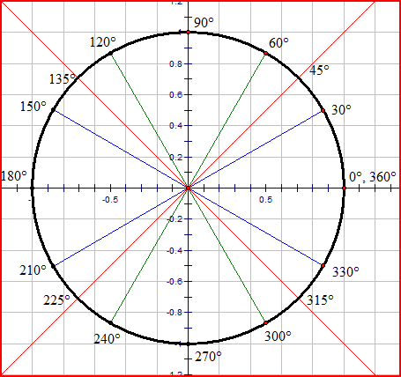

1. Duplicate this graph and circle on a piece of your own graph paper. Make the radius of your circle 10 squares long (10 squares = 1 unit).
2. Fold in the angle bisectors of the right angles formed at the origin. What angles result from these folds?
3. Use a protractor to mark angles at all multiples of 30o on the circle. Why didn’t we use paper folding for these angles?
4. Which of the angles from #6 have reference angles of 30o?
5. Which of the angles from #6 have reference angles of 60o?
6. What is the angle measure when the terminal side of the angle lies on the negative side of the x-axis?
7. What is the angle measure when the terminal side of the angle lies on the negative side of the y-axis?
8. What is the angle measure when the terminal side of the angle lies on the positive side of the y-axis?
9. For what angle measures can the initial side and terminal side overlap?