Notes on Exploring Sine and Cosine Graphs Learning Task

Supplies:
Graphing calculators or a graphing utility on a computer

Notes:
This task is designed to give students a chance to explore and make conjectures about the nature of the sine and cosine graphs. They are looking specifically for the following features: amplitude, period, frequency, horizontal shifts and phase shifts. They will continue to analyze graph features like x and y intercepts, domain and range, and maximum and minimum values.

Students are encouraged to develop these ideas by developing charts of data values and by using graphing technology. Students are not expected to create all of these graphs by hand. This is especially true for a problem like #9. While it is important for students to be able to create a graph of the trigonometric functions by hand, this should be done after they are able to identify the key features of the graph and can use these features to create the graph.

Throughout these tasks students are asked to use radians and degrees. They need to develop fluidity in thinking about measuring angles using either of these units.

Exploring Sine and Cosine Graphs Learning Task

In the previous task you used your calculator to model periodic data using a sine graph. Now you will explore the sine, cosine, and tangent graphs to determine the specific characteristics of these graphs.

- Using your knowledge of the unit circle, complete the following chart for f(x)=sin x. (Use exact values.)

x° | -2π |  |  |  | -π |  |  |  | 0 |  |  |  | π |  |  |  | 2π
sin x° | 0 |  | 1 |  | 0 |  | -1 |  | 0 |  | 1 |  | 0 |  | -1 |  | 0

- What do you notice about the values in the chart?
Possible answers: The numbers tend to repeat themselves. There is a pattern to the numbers as the angle increases. The highest values are 1. The lowest values are -1. It tends to cross the x-axis often.

- When is sin x=1? 0?
Sin x = 1 when the angle in -270° and 90°.
Sin x = 0 when the angle in -360°, -180°, 0°, 180° and 360°.

- Does sin x appear to be a periodic function? If so, at what would you consider to be its period?
Yes, the function appears to be periodic. It’s period could be 0° to 360°.

Comment: There are other answers students could give that would make sense for the period of the function. For example: -360° - 0°. If students’ answers vary this could be a good point of discussion.

- Use your graphing calculator to graph sin x. Check your mode to make sure you are using radians and make sure you have an appropriate window for your data. Use the grid below to draw an accurate graph of sin x. Make sure you draw a smooth curve.

- Study the graph to answer the following questions:

- What is the period?
The period is 2π.
- What is the domain and range?
The domain is all real numbers. The range is -1 to 1.
- What is the y-intercept?
The y-intercept is (0,0).
- Where do the x-intercepts occur?
The x-intercepts occur when x = -360°, -180°, 0°, 180°, and 360°.
- What are the maximum values and where do they occur?
The maximum value is 1 which occurs when x = -270° and 90°.

- What is the minimum value and where does it occur?
The maximum value is -1 which occurs when x = -90° and 270°.
- How would your answers to questions d, e, and f change if your graph continued past 360°?
The values would continue to occur at multiples of each of these values.

- Using your knowledge of the unit circle and radians, complete the following chart for f(x)=cos x with x measured in radians, not degrees. (Match the degrees found in the chart above.)
x | -2π |  |  |  | -π |  |  |  | 0 |  |  |  | π |  |  |  | 2π
cos x | 1 |  | 0 |  | -1 |  | 0 |  | 1 |  | 0 |  | -1 |  | 0 |  | 1

- Use your graphing calculator to graph cos x. Check your mode to make sure you are using radians and make sure you have an appropriate window for your data. Use the grid below to draw an accurate graph of cos x. Make sure you draw a smooth curve.

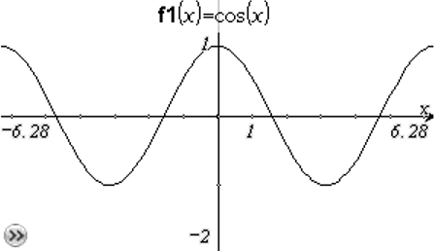

- Study the graph to answer the following questions:

- What is the period ?
The period is 2π.
- What is the domain and range?
The domain is all real numbers. The range is -1 to 1.
- What is the y-intercept?
The y-intercept is (0,1).
- Where do the x-intercepts occur?
The x-intercepts occur when x = , , , .
- What is the maximum value and where does it occur?
The maximum value is 1 which occurs when x = -2π, 0 and 2π. (Even multiples of π)
- What is the minimum value and where does it occur?
The minimum value is -1 which when x =–π and π. (Odd multiples of π)
- Picture your graph continuing past 2π.How would your answers to questions d, e, and f change?
- The x-intercepts, maximum values and minimum values would continue to occur at regular intervals.

- Re-write your answer to d, e and f and make sure to include all possible values.
The x-intercepts occur when x = +πn, where n is an integer.
The maximums and minimums occur every 2π radians.
Maximums: when x= πn where n is an even integer.
Minimums: when x=πn where n is an odd integer.

- Using your graph, find the value of cos .
Cos =

- Find all values of θ, such that
- occurs when x = +2π and when x = + 2π.

- Using your calculator, graph sin x and cos x on the same axis. How are they alike? How are they different?
Answers may vary.
Similarities include: period, max, min, overall shape
Differences include: when x-intercepts, max and min’s occur ; location of y-intercepts

- Using what you have learned about the graphs of the sine and cosine functions, practice graphing the functions by hand. You should be able to quickly sketch the graphs of these functions, making sure to include zero’s, intercepts, maximums and minimums. Be sure to create a smooth curve!

Students should not move on until they feel comfortable sketching the sine and cosine graphs. They need to use their unit circles and their basic understanding of the shape of the graph to create these quick sketches.

The graphs of trigonometric functions can be transformed in ways similar to the function transformations you have studied earlier.

- Using your knowledge of transformation of functions make a conjecture about the effect 2 will have on the following graphs of cos x and sin x. Then graph it on a calculator to determine if your conjecture is correct. Graph the parent function each time to compare the effect of 2 on the graph. (Make sure your mode is set on radians.)
These are possible student answers. Answers may vary in wording and specificity.
  - f(x)= 2sin x f(x)= 2cos x
The 2 changes the maximum and minimum values. This seems to be a stretch.

  - f(x)= sin x + 2 f(x)= cos x +2
The 2 moves the graph up two unit. This seems to be a vertical translation.

  - f(x)= sin (x - 2) f(x)= cos (x -2)
The 2 moves the graph two units to the right. This seems to be a horizontal translation.

  - f(x)= sin (2x) f(x)= cos (2x)
The graph seems to be moving faster. It repeats twice between 0 and 2π instead of just once.

Using your conjectures from above, sketch the graph of these functions. Use your calculator to check your graphs.

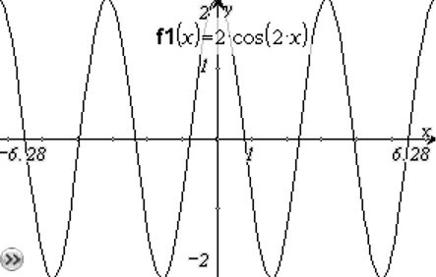
  - f(x)=2 sin(x)+2 f(x)= 2cos(2x)
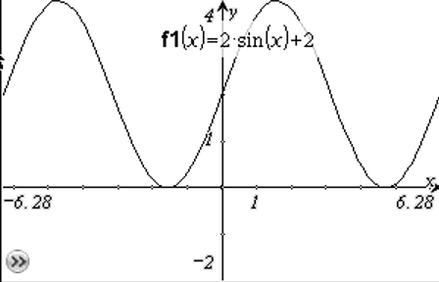

Consider the functions f(θ)=A sin(kθ + c)+h and f(θ)=A cos(kθ + c)+h. A, k, c and h have specific effects on the graphs of the function. In trigonometry we also have special names for them based on their effect on the graph.

- The amplitude of the function is |A|. Look back at 9a: f(x)= 2sin x and f(x)= 2cos x
  - What is the value of A? How is it related to your graphs?
A = 2 in these equations. The graphs now have maximums at 2 instead of 1.

  - How is the amplitude related to the distance between the maximum and minimum values?
The max is 2. The min is -2. The distance between the max and min values is 4. 2 is half of that value

  - What effect does A have on the effect if A<0? Graph y=-2sin x to test your conjecture.
When A is negative it reflects the graph over the x-axis.

- The period of the function is related to the value of k. Look at 9d: f(x)=sin(2x) f(x)=cos(2x)
The period of the sine and cosine function is defined as , where k>0.

  - When x was multiplied by 2, the function repeated itself twice in the usual period of 2π. What is the period of the functions in 9d?
The period is π. This can also be found by substituting k=2 in the definition of period: = π

  - Using your calculator look at the graph of the functions f(x)=sin x and f(x)=sin(4x).
Notice the graph repeats 4 times in the length of time it took sin x to complete one period. So the period of f(x)=sin(4x) is or .

- Look back at 9c. The 2 shifted the graph 2 units to the left. A horizontal translation of a trigonometric function is called a phase shift. When calculating the phase shift you have to consider the value of k, which determines the period of the function. The phase shift = .
If c>0, the graph shifts to the left.
If c>0, the shift is to the right.

  - Graph f(x) = sin x and g(x)=sin(x+2)on the same axis using radians.
For what values of x is f(x) = 0? For what values of x is g(x) = 0?
  - What do you notice about your answers to II and III?
  - Use the table feature on your calculator to investigate this relationship for values other than f(x)=0.

- Graph y=sin x and y= cos x on the same axes. How can you use the sine function to match the graph of the cosine function? How can you use the sine function to match the graph of the cosine function?
The functions are related to each other by a phase shift.
One possible answer: sin x = cos (x - ).
There are multiple solutions to this, including changing the phase shift on the sin function to match the cosine function.

Comment: Changing the type of line used by the graphing calculator to represent the two functions can help students identify that the functions truly lie on top of each other when they see only one graph appear on their grid. On a TI-84, arrow to the left on the y= screen until the cursor is blinking on the line. Press enter the style will change. Continue pressing enter and you will get multiple options for how the line can appear.

- In trigonometric functions, h translates the graph h units vertically.
  - What effect does 2 have on the graph of the function y = f(x) + 2?
The 2 translates the graph two units vertically upward.
  - What effect did the 2 have on the graphs for 9b?
The 2 translated the graph two units vertically upward.
  - What happens when h > 0? h < 0 ? h = 0?
If h=0, no translation occurs.
If h>0, the graph translates vertically upward.
If h<0, the graph translates vertically downward.

- Look at this equation that models the average monthly temperatures for Asheville, NC. (The average monthly temperature is an average of the daily highs and daily lows.)
Model for Asheville, NC where t = 1 represents January

  - Find the values of A, k, c, and h in the equation.
A=18.5; k = ; c = -4; h = 54.5

  - Graph the equation on your calculator. The maximum and minimum values of a periodic function oscillate about a horizontal line called the midline. What is the midline of the equation modeling Asheville’s temperature?
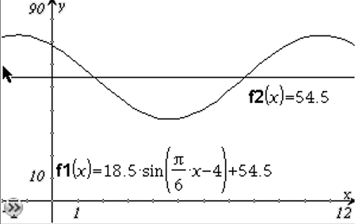
The midline is y=54.5.

  - How it the value of the amplitude related to this midline?
The maximum value is 18.5 degrees above the midline and the minimum value is 18.5 degrees below.
- How is the amplitude related to the midline of f(x)=sin x? f(x)=3sinx + 2? f(x)=-4sin x -2?
For f(x)=sin x, the midline is y = 0. The amplitude is 1. The max is 1 and min is 1.
For f(x)=3sin x + 2, the midline is y = 2. The amplitude is 3. The max is 3 above the midline at 5 and the minimum value is 3 below the midline at -1.
For f(x)=-4sin x - 2, the midline is y = -2. The amplitude is 4. The max is 4 above the midline at 5 and the minimum value is 4 below the midline at -6. The negative flips the graph but doesn’t change the max and min values.

- State the amplitude and period of the following functions describe the graph of the function.

  - f(θ)=2sin(6θ) A = _2_ period = ____

period = = =

  - f(θ)= -4cos(1/2 θ) A = ___4____ period = __

period = = =

The frequency of a sine or cosine function refers to the number of times it repeats compared to the parent function’s period. Frequency is usually associated with the unit Hertz or oscillations/second and measures the number of repeated cycles per second. The frequency and period are reciprocals of each other.

Example: Determine the equation of a cosine function that has a frequency of 4.
The frequency and period are reciprocals of each other so the period = .
Since 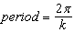, we can replace the period with and solve for k.
If 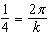, then .
The cos function with a frequency of 4 is f(θ)=sin(8πθ) .

- Find the equation of a sine graph with a frequency of 6 and amplitude of 4.

The frequency and period are reciprocals of each other so the period = .
Since the , we can solve for k.
If , then k = .
Since the amplitude is 4, A = 4.
F(x) =4 sin

